Team Inventory

Geo Learn

September 26, 2019



Mentor: Fabio Santos

Sponser: Dr. Chris Doughty

Team members: Samuel Prasse (lead), Kaitlyn Grubb,

Tyler Pehringer, Joshus Tenakhongva

**OverView:** The objective of the team inventory is to introduce the team members, as well as their skills and academic background that could be used as an important asset to the project.

**

NAU - Computer Science

Peoria, Arizona

sap353@nau.edu | 623.249.8095

**Education:**

* Liberty High School, Peoria AZ (3.6)
* Glendale Community College
  + Statistics
* Northern Arizona University
  + Algorithms
  + Advanced Web Programming
  + Operating Systems

**Work Experience:**

* Northrop Grumman - Aerospace Sector (2017)
  + Created a tool to aid in the development and efficiency of producing parts through investments in capabilities over time.
* Northrop Grumman - Aerospace Sector (2018)
  + Utilized the R programming language to create a text cleaning method – supporting Data Integration & Visibility team. Improved leadership abilities and team building skills.
* Northrop Grumman - Aerospace Sector (2019)
  + Wrote and edited several programs in Java language to aid in the development and delivery of the Software. Created an equipment package to interface with hardware and provide a Modbus communication protocol.

**Skills:**

* *Leadership*: Placing myself into stressful situations in sports, work, and school where I took responsibility for myself and my peers to accomplish a task.
* *Programming*: I find my skills in programming do not differ with different languages as I can produce high quality work with any project I am given.
* *Communication*: My communication skills have drastically improved in the professional workplace over the past three summers working on teams and collaborating with management.

**Other Interests:**

* I am a very passionate and dedicated person and strive to better myself daily. Whether that be mentally, physically, or academically, I hope that my mentality is thought provoking to others and encourages them to be the best person they can be.

**

NAU - Computer Science

Gilbert, Arizona

kcg222@nau.edu | 480.277.9501

**Education:**

* Campo Verde High School, Gilbert AZ (3.6)
* Northern Arizona University
  + Machine Learning
  + Mobile Application Development
  + Operating Systems

**Work Experience:**

* CS126 Lab Assistant - Northern Arizona University (2018 - 2019)
  + Teach Python to the CS 126 students here at Northern Arizona University. Give a lecture before every lab. Answer coding questions and general concerns. Have a team meeting with CS126 instructor, Nakai to help further develop and improve the lab.
* Coding for Dr. Winfree - Northern Arizona University (2019)
  + Continued coding a previous capstone project using Django/Python as the main language and framework. Continued improving documentation and writing new documentation.
* Coding for Dr. Doerry - Northern Arizona University (2019)
  + Helped develop a website for the people who run trips through the Grand Canyon River. I primarily work in Ruby and HTMLto develop a website that works with Postgres to allow users to locate, change, and assemble trips for the river.

**Skills:**

* *Presentation and communication*: Due to teaching CS126 labs twice a week and presenting in class my presentation skills have increased allowing me to be calm, prepared, and concise.
* *Code Organization*: Due to working on projects over the summer with many files of code I have learned the best ways (and worst ways) to structure, organize, and write code.
* *Website Development*: Two of my jobs require me to develop a website. This along with the Northern Arizona University web development class, I have learned good UI, a solid understanding of HTML, and how to collaborate on a web development project.

**Other Interests:**

* I often like to keep busy. I am usually thinking about projects I am working on and how to apply what I have learned to previous things I have coded. I like to finish projects and it annoys me deeply to leave a project I know can be finished incomplete.

**Tyler Pehringer**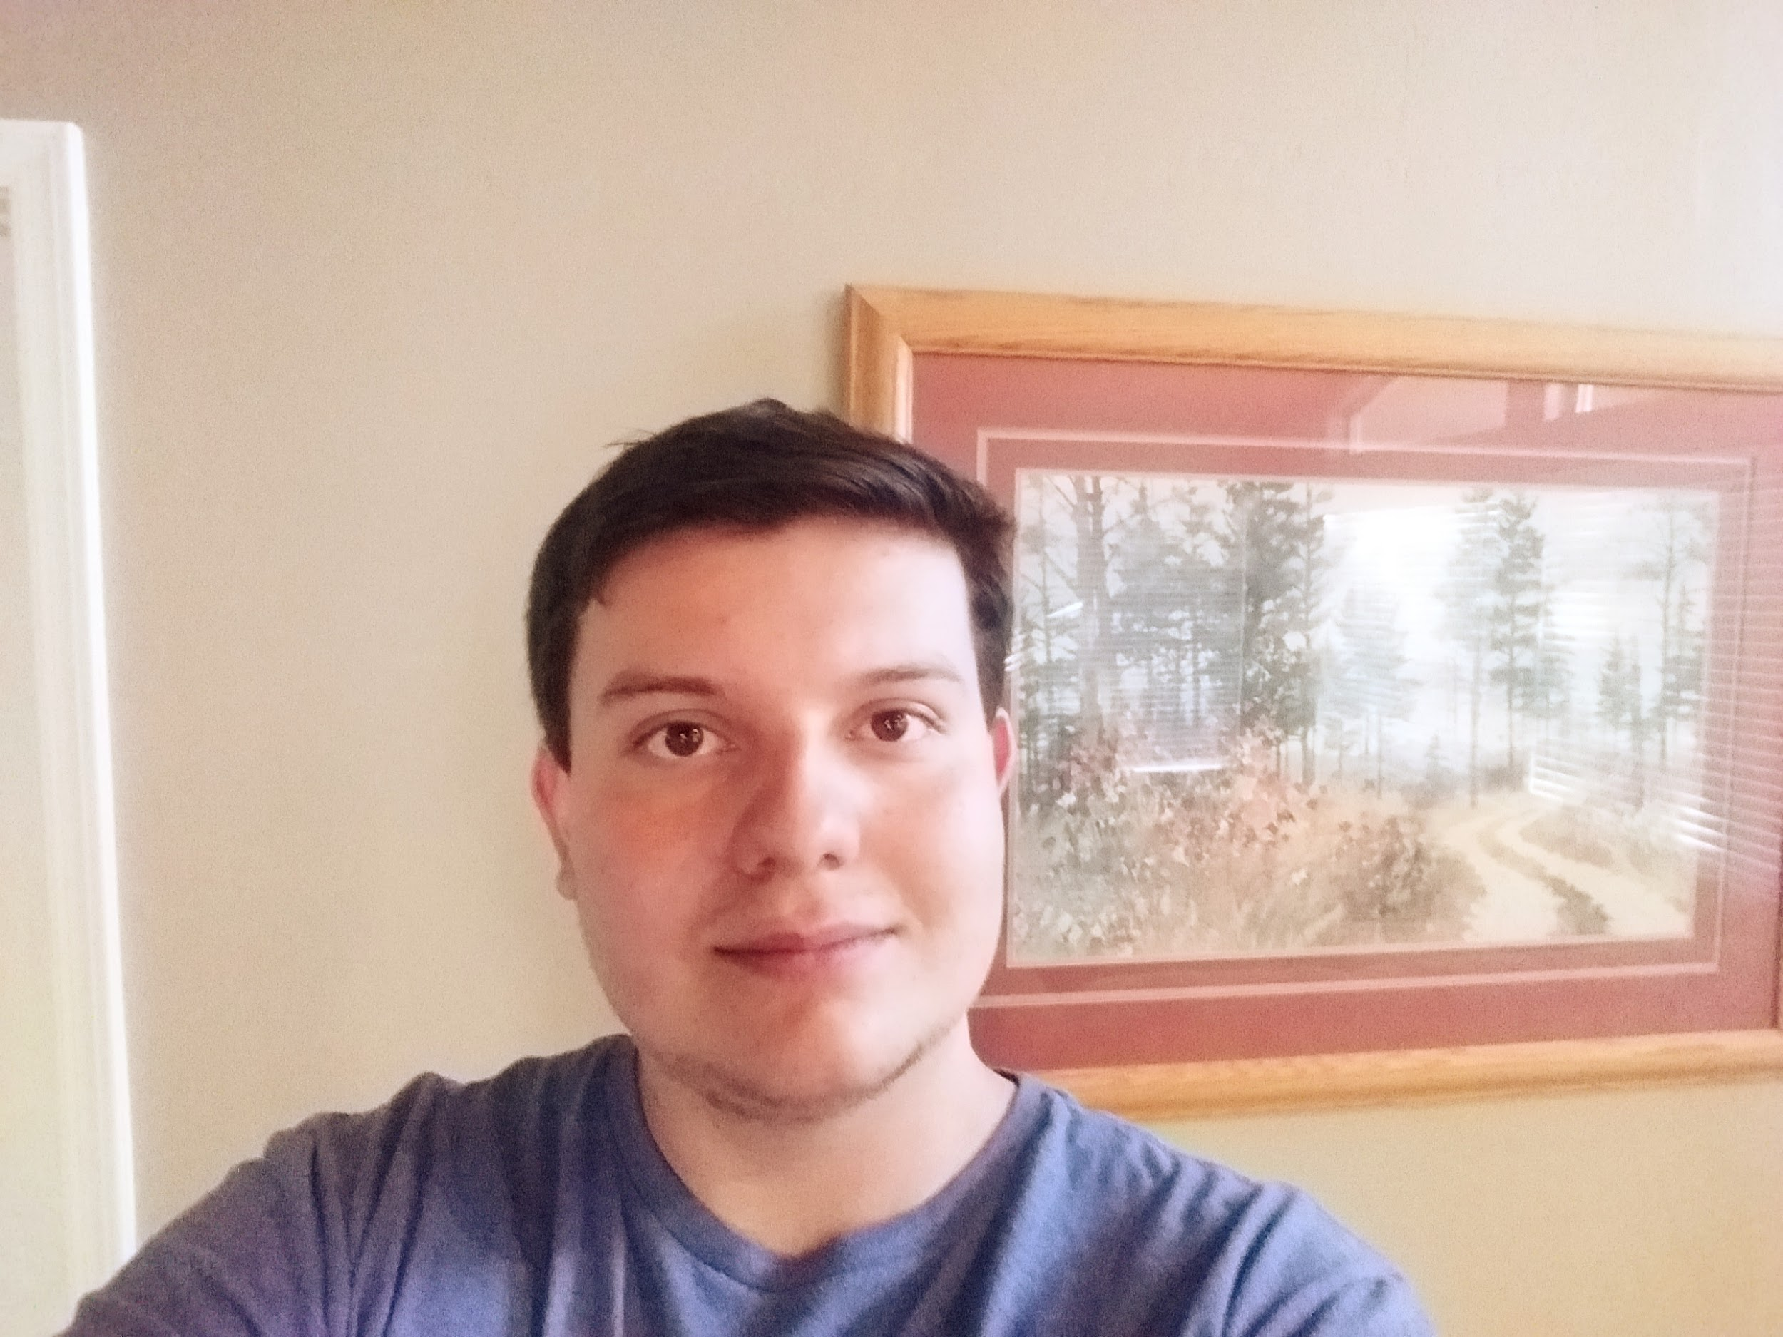

NAU - Computer Science

Prescott Valley, Arizona

tjp278@nau.edu | 928.925.4661

**Education:**

* Bradshaw Mountain High School (3.78)
* Northern Arizona University
  + Software Engineering
    - This class has taught me how to work better in a group and how to plan big projects as a group. This class has also helped me with any conflict resolution that could be helpful when it comes to group work
  + Computer Networks
    - This class has taught me how to use different tools that will help me navigate internet applications that can be used for the project at hand.
  + Databases
    - This class has taught me how to better organize any form of data that is given for better access and precision for any user.

**Skills:**

* *Organization*: I believe this skill will help the group by allowing them to understand what tasks need to be done in the order that is required.
* *Technical Writing*: I believe that my skills to write professional documents has improved over the past four years. I also believe that I can deliver any important information in a professional manner.
* *Programming*: I believe my skills in programming have improved over the years by using different methods of planning that have allowed me to create cleaner looking code.
* *Communication*: I believe that my communication skills will be a major asset to the group and the project as a whole. I make sure that I reply back to any concerns, questions and other forms of messages in a timely manner.

**Other Interests:**

* I am very interested in taking on new projects to better my skills above.
* I want to be able to create new applications that improve people's lives by either giving them a better understanding of the world or at the least, making their everyday lives easier.
* I want to continue learning new techniques that will help me in the field.

**Joshus Tenakhongva**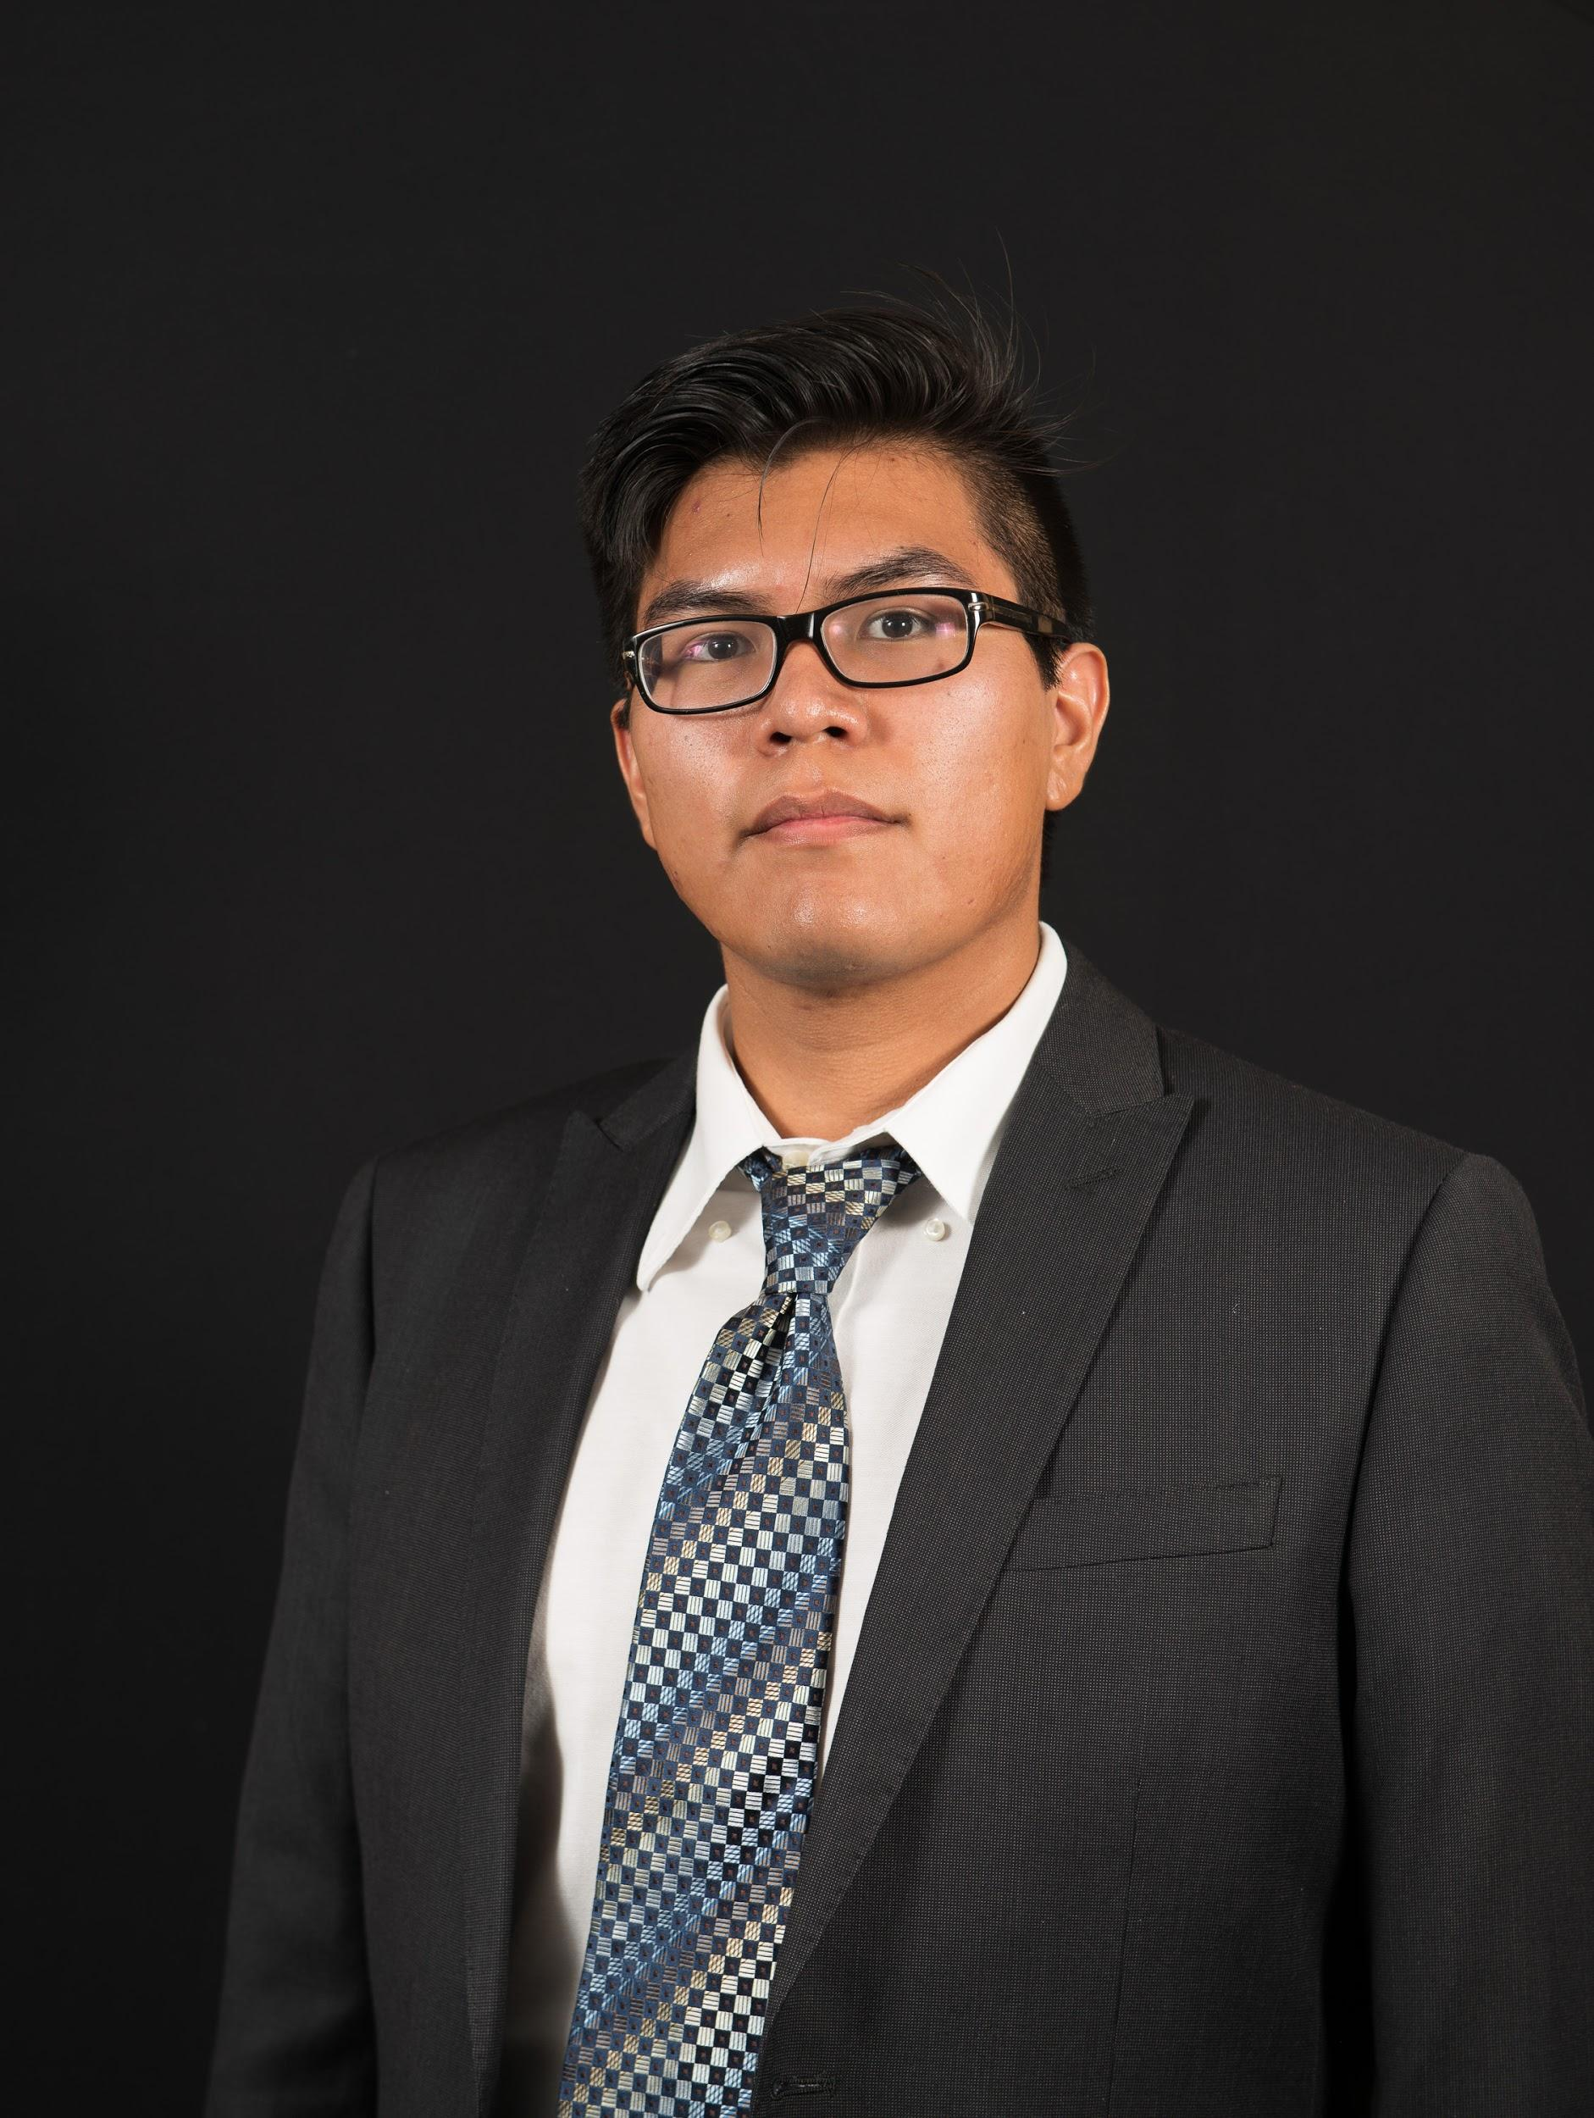

NAU - Applied Computer Science

Kayenta, Arizona

jtt75@nau.edu | 435.817.6383

**Education:**

* Monument Valley High School. Kayenta, AZ (3.69)
* Utah State University. Blanding. Blanding, UT (3.78)
* Northern Arizona University. Flagstaff, AZ (3.70)
  + *Software Engineering:* This class gave students a taste of what it’s like to work in a professional setting with other programmers on a long-term project.
  + *Web Programming:* This class introduced me to the structure of the web and how websites are presented and coded.
  + *Operating Systems:* This class challenged my coding ability and forced me to adopt good coding habits, the usage of Git, and code with the mindset that a project will continually be developed and build upon rather than thrown away after an assignment is due.

**Skills:**

* *Planning*: Thinking through a solution to a problem step-by-step in a simple, guided way. It’s important to know what your solution and algorithm is before you start coding. Using visuals and charts to map out your solution is an effective way to ensure a good solution is implemented.
* *Teamwork*: Working with others to combine our skills and cover each other’s deficits is how everyone works in the industry. It’s important to have clear, efficient, and effective communication with others and ensure that everyone is working with the same goal in mind.
* *Programming*: Being able to code effectively using good habits, stick to stylesheets, and understand the technologies that the code will be affecting or interacting with.
* *Visual Design*: An understanding of composition, color theory, and shape design in order to create appealing visuals.

**Other Interests:**

* Learning the most I can about the field of computer science generally in order to determine what parts pique my interest and learn techniques that may be applicable universally
* Designing games and game components in order to develop my higher level thinking when planning the interact of game mechanics, my lower level thinking in planning how the mechanic will work, and for fun.